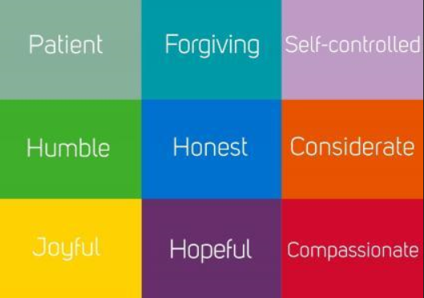

The 9 Habits Summer Assignment
Making the World a Better Place

Name:________________

Make the World a Better Place
Your summer assignment is designed to ensure that you make the most of your time off school, whilst at the same time preparing you in developing the 9 habits that you will use in every lesson during your learning journey at Oasis Leesbrook.
Your Challenge
Over the summer holiday your mission is to complete a selection of the 20 challenges listed in this booklet. If you have already completed some, move on to the ones you have not done. Don’t always go for what you think will be the easiest, the ones you think are harder are more likely to be more rewarding. Give as many as you can a try, but aim to complete at least 8 before you return in September.
It’s easy to think that school is all about good grades. Of course academic success is essential, however this is not achieved through study alone. All of the tasks are designed to help you on your journey to becoming a more mature learner and to remind you of other things in life that are important.
Recording your Experiences
Once you have completed your challenges, use the double page in this booklet to record:
- What you did
- What happened
- How it made you feel
However many challenges you complete you should create just one page in this booklet for your final task. This should be a visual way of showing your best challenges you choose and what you did to complete them. Think carefully about your presentation, think like an artist! You will have an opportunity to share your experiences when you return to school.
For parents
We hope that students find the challenges listed both beneficial and rewarding, as well as memorable. The challenges should all be possible with little help from adults, and require very little resources. If parents of siblings do want to join in then all the better!
Enjoy your summer!
The Challenges
Watch the news  (Humble) | Tell someone how much they mean to you  (Honest) | Do a household task without being asked (e.g. washing up, cleaning  (Considerate) | Dream about your future and decide what you need to get there  (Hopeful)
Read a book by an author you’ve not heard of  (Joyful) | Write to your MP about an issue you think is important  (Compassionate) | Learn a poem of by heart  (Patient) | Write a list of things you would like to achieve by the time you leave Oasis Leesbrook  (Hopeful)
Cook a meal for somebody to make them feel better  (Considerate) | Handwrite a letter to somebody and post it  (Patient) | Make a list of all the positive things you can be thankful for  (Humble) | Grow something that you can eat  (Joyful)
Bake a cake for someone  (Considerate) | Try a new food you can’t pronounce  (Joyful) | Learn to play a song on a musical instrument  (Joyful, Patient) | Skim a stone across water  (Joyful)
Talk to an older relative about when they were young, and what school was like for them  (Joyful) | Research a charity and organise a fundraising event  (Considerate, Compassionate) | Forgive somebody if they upset you  (Forgiving, Self Controlled) | Pick up somebody else’s litter  (Forgiving, Considerate)

Challenge 4
What you did

What happened?

How it made you feel

Challenge 3
What you did

What happened?

How it made you feel

Challenge 2
What you did

What happened?

How it made you feel

Challenge 1
What you did

What happened?

How it made you feel

Challenge 7
What you did

What happened?

How it made you feel

Challenge 8
What you did

What happened?

How it made you feel

Challenge 6
What you did

What happened?

How it made you feel

Challenge 5
What you did

What happened?

How it made you feel

Visual Record of your challenges

On the following page create a visual record of your challenges. You can do this however you like, here are some suggestions!

Draw or paint a picture of where you completed your challenge
Take photos as you complete the challenge. Print and stick in to make a collage

Draw the words you used to describe how the challenges made you feel in a creative colourful way
Glue in images from magazines or newspapers that link to your challenge.

Your Visual Record

