Oasis Academy Leesbrook
Maths Exam Support
And Guidance

All students have completed a number of GCSE Mock exams this academic year at either Foundation or Higher tier. These papers are individually analysed to identify strengths and weaknesses for students. Based on their mocks, teachers have been tailoring their lessons to help students with their areas for development and challenging their understanding of particular topics.

It is important that students emphasise their practice on their weaknesses rather than their strengths.

The Maths department have also carefully analysed the mock exam data to understand where strengths and weaknesses are at a whole class level. Maths teachers of Year 11 will set regular homework on Hegarty Maths to cover any specific topics that have been identified as areas to improve for the class your child is in.

Past papers and exam style questions will be completed on a regular basis in lessons to prepare students for their exam. The best way to revise for GCSE Maths is to complete as many past papers as possible. This helps to develop confidence in answering questions similar to the exam.

Our students have a wide range of resources available to them to aid their revision, these include:
- AQA Pre-released information
- Their class-books
- Hegarty Maths
- MathsGenie
- OnMaths
- Corbett Maths

Below are the dates for the Summer 2022 math exams:
- Paper 1 (non-calculator) Friday May 20th
- Paper 2 (calculator) Tuesday May 7th
- Paper 3 (calculator) Monday May 14th

Students sitting exams this year, will also receive a formula booklet which is on the next page.

Foundation Formula Booklet
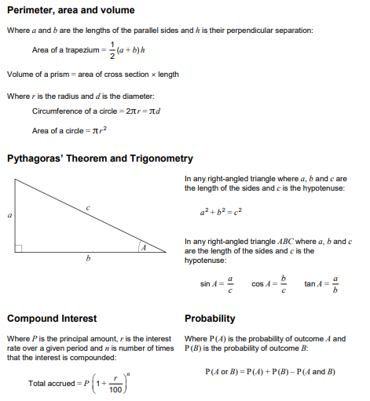

Higher Formula Booklet
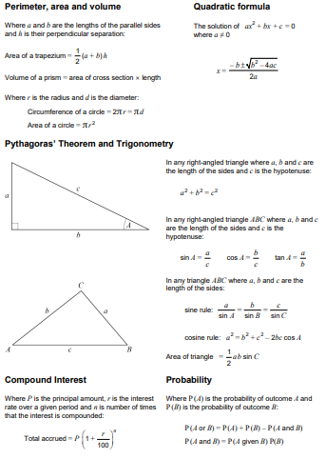
AQA Pre-release information
All exam boards have released information relating to which topics, will appear on which paper. This means that students will have a better understanding of what to expect this year compared to previous years.
The following two pages show a breakdown of this information for each paper, students should use this information to help guide them as to which topics they need to revise.

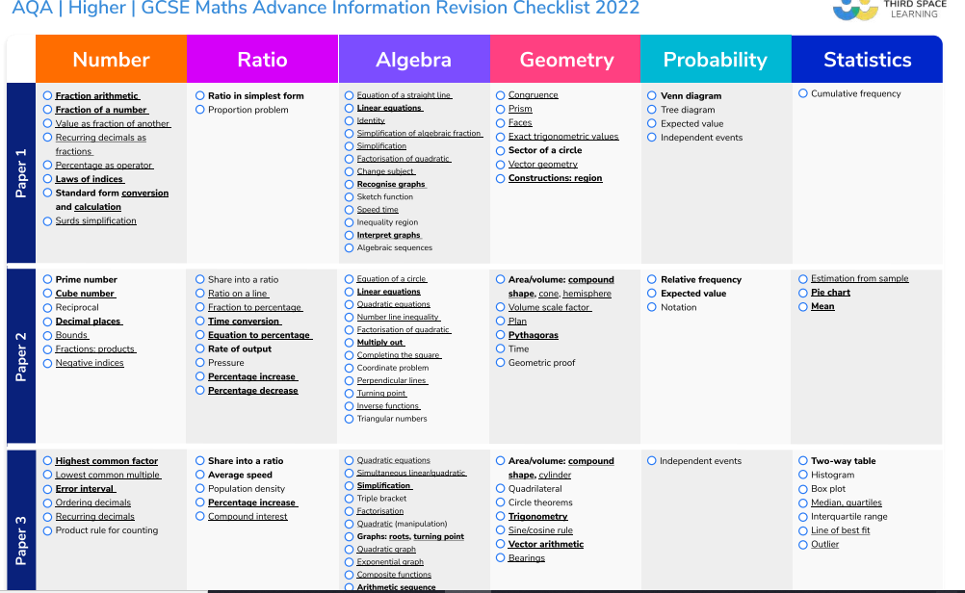
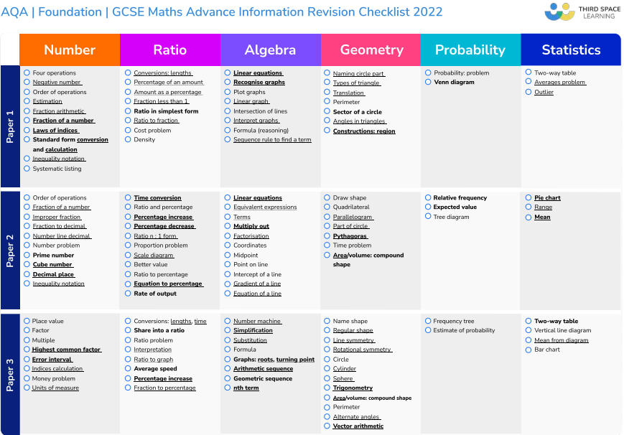

Using Your Class-book

When using your class-book to revise, it is important that you don’t just read the questions and answers and move on. For this method to be effective you must:
- Look at an example and any notes you have made.
- Check that the working out makes sense
- Go to a similar question, cover up the answer and working out
- Try the question
- Uncover the answer and working out
- Does your answer match?
- If your answer does not match and you can’t remember how to do it, go to the Hegarty page on this booklet for help or speak to your teacher as soon as possible

Hegarty Maths
Your teacher will have been setting homework weekly on Hegarty Maths during this academic year. Each homework will have been marked as soon as it was completed to give you an idea of how well you understood the topic. To see which tasks you have completed this year click on the My Scores tab at the top of the page.

You can retake a quiz as many times as you like, and the questions will differ each time which really helps you to understand the method involved.
Each quiz also has an optional video to watch. When watching the videos, make sure to make notes, not just copy down questions and answers. Making notes will help link different parts of the method together and aid your memory when you’re revising.
Each Sunday, Hegarty will automatically assign you a revision task. This task is based on questions you have gotten incorrect in the past. This is an excellent revision tool to practice topics you haven’t mastered yet, make sure to click the get help button for any question you don’t understand, this will take you to a video which will help you succeed.
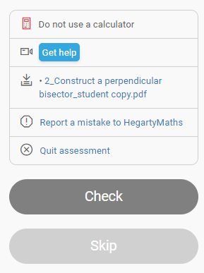
You can use Hegarty to revise any topic, not just the task your teacher has set each week. Once you log in, there is a search bar at the top of the page, use this to begin typing any topic you want to practice. You can also use the Choose Lesson tab on the top left to choose any topic to revise.
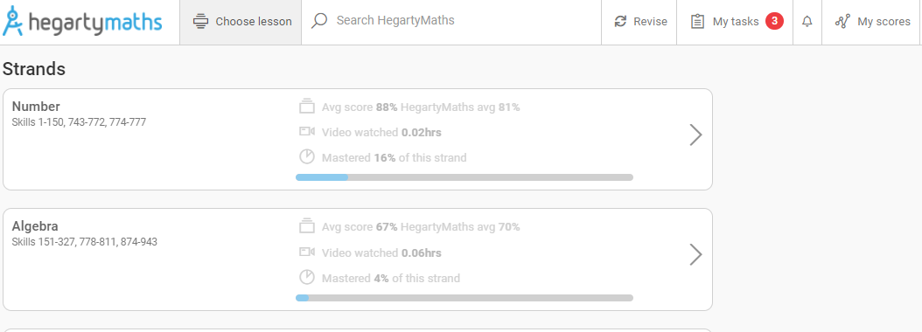
On the next few pages you will find each topic and the corresponding Hegarty maths clips.

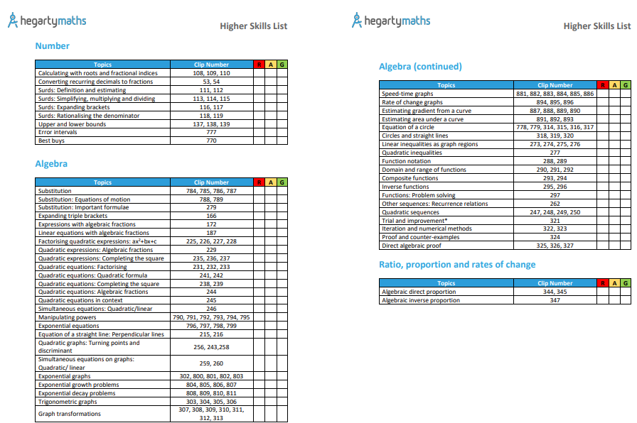
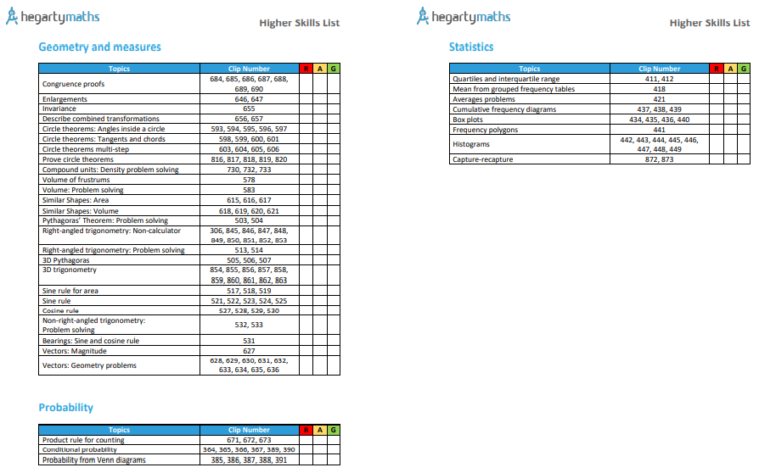
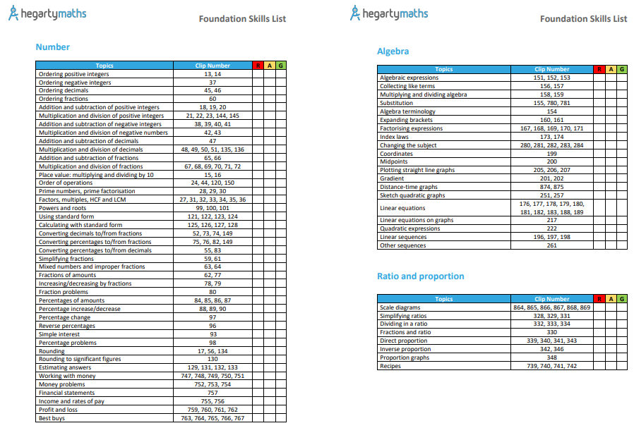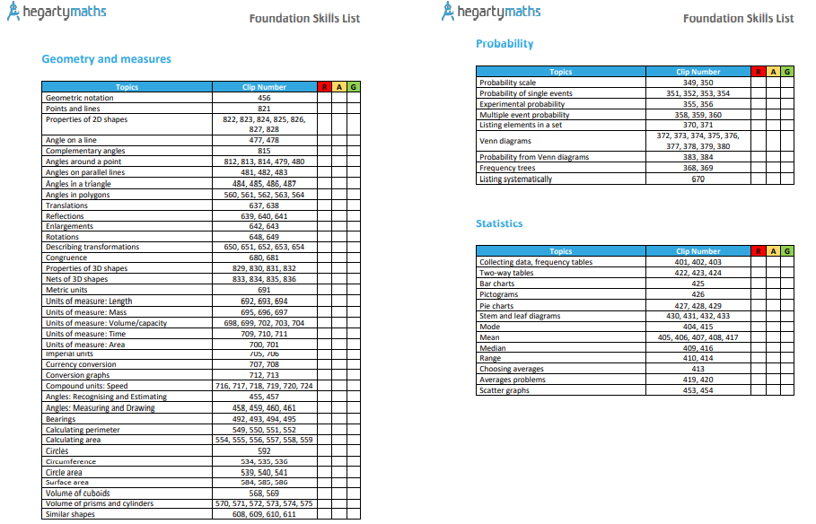
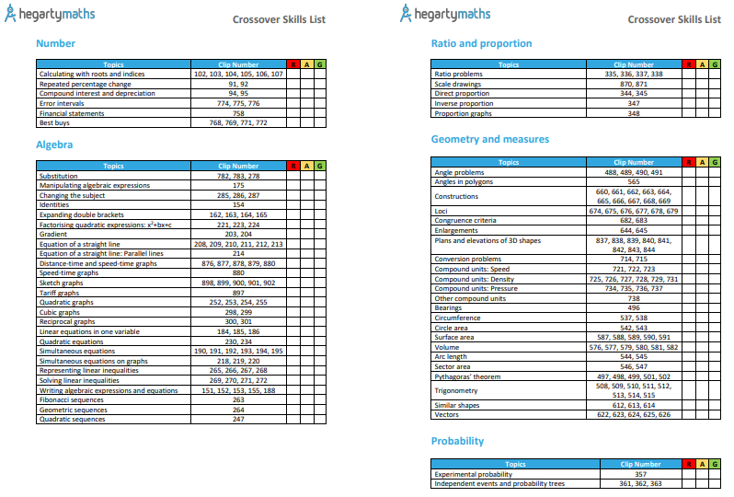

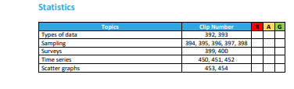

OnMaths
One of the (free to use) websites that will help you practice past papers is OnMaths.com
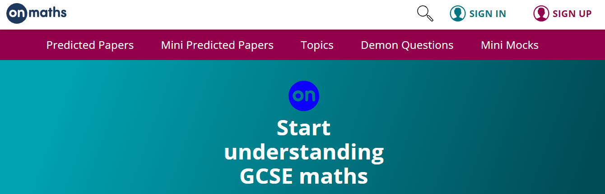
On this website you can find Predicted Papers. These papers will be based on the pre-release information provided by AQA as to which topics appear on which paper. As you complete the paper, it will grade it for you, this grade is purely for that individual paper.

There is also an option to complete Mini Predicted Mocks, so they are shorter papers instead of the full 90minute/80mark papers.

You can also find exam style questions on different topics if you want to practice a certain topic before completing an exam paper.

The section intitled Demon Questions is a bank of past paper questions that year 11’s across the country struggled with. It is a good idea to have a look at these questions and challenge yourself.

Maths Genie
On this website you can find
- Past papers with mark scheme and solutions
- Videos linked to every topic Grade9-1
- Exam style questions linked to every topic Grade9-1

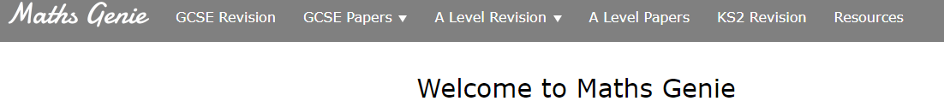

When you click on GCSE Revision, the next page will show a list of every topic from Grade 1 – Grade 9.

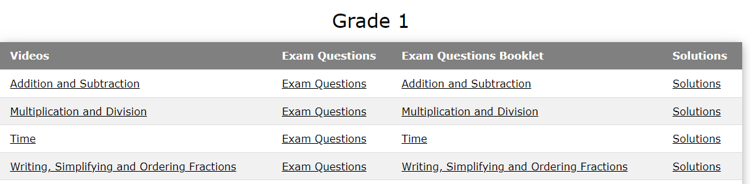

You do not need a printer to complete these tasks, use your class book. It may be helpful to reference which topic/grade you are working on, so that you can ask your teacher about anything you are unsure of.

Unlike OnMaths, Maths Genie will not grade the papers for you. You will need to use the mark scheme to mark your paper/check your answers. Pupils may find mark schemes difficult to navigate, therefore if you need any help with this, see your teacher at the earliest opportunity.

Corbett Maths

Corbett Maths is another free website which will help you with your revision. Like Maths Genie, Corbett maths has worksheets, videos, and practice papers for you to work through. At the bottom of each worksheet there is a link to an answer page so you can mark your work to see how well you have done.
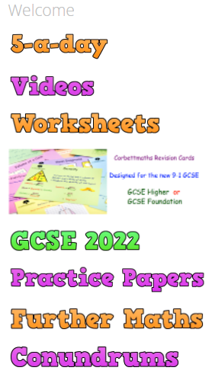

The 5-a-day section is 5 questions, all different topics, which can be used as short bursts of revision. There is a 5-a-day task for each day of the year. The sections are split into Numeracy, Foundation, Foundation Plus (crossover), Higher and Higher Plus, try to aim to do a range of these. For example, if you are sitting the Foundation tier, aim to complete tasks from Numeracy, Foundation and Foundation Plus. This will ensure you have covered more topics that may appear on your exam.

